Magic of Savings
This Holiday Season 2021

Through These Hard Times, Heal Through Music…
Buy One Get One Half Off!

You can get one song full price and one song Half Off the original price! This will include, both recordings. See other side for more details.

Added Bonus!
You can have a video made and featured on our YouTube Channel for an extra $99. Our Video Production Master will personally make a video specifically for your song! (You can also request a theme as well)

Sample Video Click Here

News and offers!
Until December 31rst only, you can use code B1G1 to get the Buy One Get One Half Off Deal on your song poem. Total for the first song is $199. Half off for $99! For only $79 more you can add a lead sheet to your order for one song.
This year Magic Key has been working on some very exciting projects. Soon to come out an Audio Book recorded by Magic Key. More details coming soon! As ever our video expert is assisting in making your songs into videos!
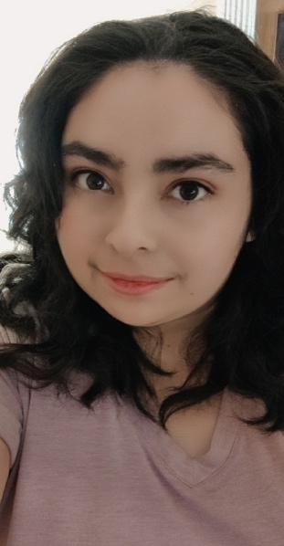
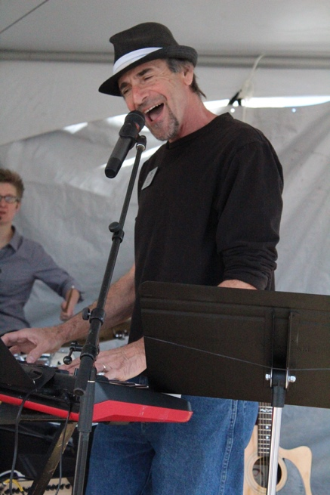

We would like to introduce our Video Production Master. Sarah Nay, (aka Silver Fox). Just like her father David Fox her passion in life is Music Production. She’s currently getting her bachelors from FullSail University. While keeping a full-time job, she makes time to work for Magic Key. She makes each video a priority in making it the best unique video just for you.

Here is two of our fine actors working on the Audio Book, follow our website for updates on the release! The book is called: No Regrets By Ty Isham.
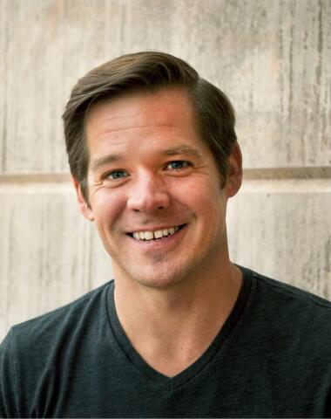
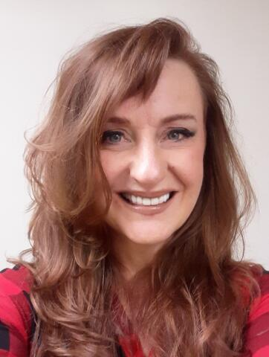

Follow us on Facebook! Visit Our Website!
redrockrecords.com
Email: magickey@redrockrecords.com Address: 405 South Mesa Hills Dr. Cedar City UT, 84720

